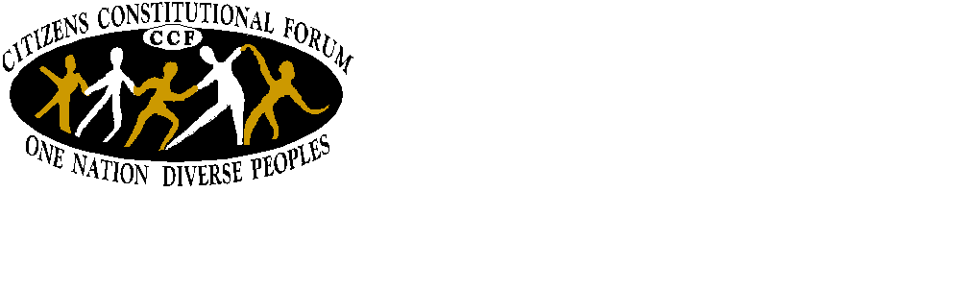Application Form CCF Youth Forum 2011
Citizens’ Constitutional Forum Limited
23 Denison Road, PO Box 12584, Suva, Fiji
Phone: [679] 3308 379 Fax: [679] 3308 380
E-mail: ccf@kidanet.net.fj
Website: www.ccf.org.fj

Theme – “Dialogue & Mutual Understanding”
In celebration of the International Year of Youth which ends on the 11th of August 2011.

What is CCF?
The Citizens’ Constitutional Forum (CCF) CCF is a non government organization that advocates and educates the public on democracy and multiculturalism in Fiji. CCF’s vision is to make Fiji a nation where people live together in equality, justice and peace, respecting the rule of law that guarantees democracy and good governance.

Who are we targeting?
Young people from the ages of 17-25 years old;
This Youth Forum targets Young Leaders, Youth workers & young people in rural & urban communities; young people that are involved in other stakeholders and organisations.

When will it be held?
Will be held from the 09th-13th May, 2011

What we take care of?
CCF will meet all costs of the training which includes: training materials; breakfast, lunch, morning tea, afternoon tea and dinner.

How will we select participants?
We select up to 40 participants with different background of work and living; we are open to young people with any level of education, who live in rural and urban communities and that are passionate to work with and for young people. We aim to recruit equal number of men and women.

When will I know if I am selected?
We will contact you by March 2011 to advise you if you have been selected
If selected?
You must be available for the 5 days of the Forum; at this forum you will meet other young people, discuss issues that affect your community, share ideas and experiences, build skills and participate.

How do I apply?
You can apply by filling in this official application form and sending it to us before the close of business on February 25th, 2011 by email (ccf@kidanet.net.fj / losana@ccf.org.fj), fax (3308380) or mail (P.O.Box 12584, Suva).

Application Form

SECTION 1: Personal Details-

Last/Family Name- First/Given Name-

Please write your preferred name (if you’re called other than your name)-

Gender? Male Female Age?

Date of Birth?

Communication Details-

What is the best way for CCF to contact you? (Please tick one of the boxes)

Email- Fax- Phone- Mail-

Email Address-

Mailing Address-

Phone Details - Mobile-

Physical Mailing Address–

Education-
We are open to young people with any level of education;

Have you ever attended school? Yes- No-

What is the highest level of education which you have completed?

Primary- Secondary- Tertiary-

Are you currently studying? Yes- No-

If yes, at what level are you currently studying?

Primary- Secondary- Tertiary-

Please describe your field of study?

Community & Organisational Support-

Do you work with an organisation? Yes- No-

What is the name of the organisation?

Are you part of a youth group? Yes- No-

What is the name of the group?

SECTION 2 – YOU, YOUR COMMUNITY AND YOUR VISION

- How would you describe the community that you live in; and what you are most proud of?

- What do you understand about Good Governance, Active Citizenship, and Human Rights?

- What are other issues that you feel young people are concerned about?

- Why do you want to participate in the CCF Youth Forum and what would you take back to your community after the Forum?

Permission to use responses:

Do you give permission for CCF to publish your responses? Yes- No-

I, __________________________________________________ (your name) declare that everything in this application is true and correct.

Signature-___________________________________________ Date-______________

Send your applications to:

Email- ccf@kidanet.net.fj / losana@ccf.org.fj

Fax- 3308380
Mailing Address- Citizens’ Constitutional Forum
P.O. Box 12584
Suva.
Titled- CCF Youth Forum application
Or drop application at 23 Denison Road, Suva.

APPLICATION CLOSES 25TH FEBRUARY, 2011

For more information contact Losana- 3308379 or email- losana@ccf.org.fj

